**NEMO**

***Neuro-Emotive Mobile Operator***

***Category: 5.3. Hardware Control Project Type: Autonomous Robotic System for Proactive Elderly Care***

***Mission: Bridging the gap between advanced AI and physical safety for the elderly.***

***About the Project: NEMO is an autonomous robotic platform designed to provide a proactive safety net. Unlike passive systems, it utilizes Hybrid Cloud Intelligence to detect health emergencies and execute hardware-level rescue protocols via GSM and autonomous navigation.***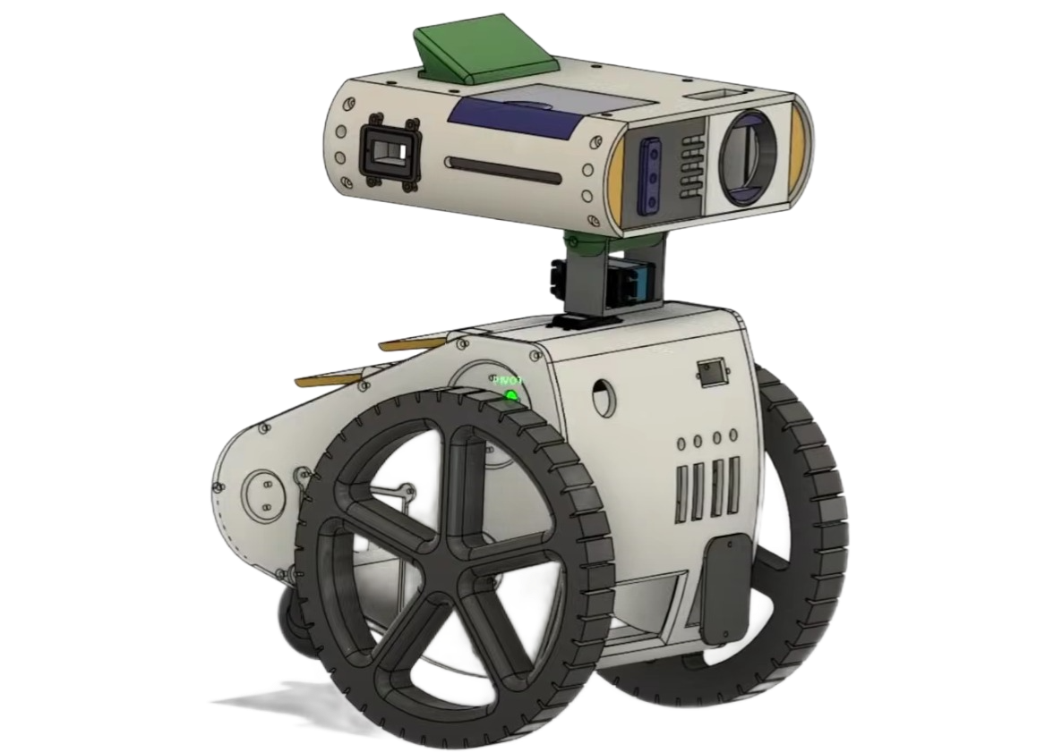

***Design Attribution: The aesthetic concept of NEMO is based on the original design from the film "The Lightning Code". The physical structure was independently engineered and adapted for real-world hardware integration by the project team.***

***Project Team:STEAM_VICTORY***

***MENTORS: Mukhtarov Timur***

1. ***Jahangir Aushakmanov - Lead Hardware Engineer & CAD Designer***
2. ***Alimbatyr Tursumbekov - Software Developer & AI Integration Specialist***

***Organization: Alimkhan Ermekov School-Lyceum City: Karaganda, Kazakhstan Year: 2026 12.02.2026***

**Project Title:** NEMO (Neuro-Emotive Mobile Operator) **Category:** 5.3. Hardware Control **Status:** MVP (Phase 1: Hybrid Architecture)

### **1. ABSTRACT**

NEMO is a modular autonomous robotic assistant designed to mitigate the risks associated with elderly people living alone. The project represents a technological shift from passive monitoring systems to proactive care. Utilizing a **Hybrid Edge-Cloud Architecture**, the robot functions as a mobile sensory node that combines the reliability of low-level hardware control (autonomous GSM emergency calls) with the computational power of Cloud AI (Gemini Vision) for health monitoring.

The current MVP demonstrates a robust telepresence system and safety protocols, including a **multi-channel notification system (Telegram + GSM)**. The software architecture is built upon **ROS 2 standards**, laying the foundation for fully autonomous Lidar-based patrolling in the subsequent development phase.

### **2. PROBLEM STATEMENT & RELEVANCE**

The global "Silver Economy" is currently facing a systemic crisis characterized by three factors:

1. **The "Long Lie" Syndrome:** According to WHO data, 30% of individuals over 65 fall annually. Without immediate assistance during the "Golden Hour," survival and rehabilitation rates drop by 40%.
2. **Device Abandonment:** Research indicates that 80% of seniors forget to wear panic buttons or smartwatches while at home, rendering passive safety systems ineffective.
3. **Social Isolation:** Lack of regular interaction accelerates cognitive decline, contributing to conditions such as dementia and Alzheimer’s disease.

**Proposed Solution:** NEMO acts as a proactive agent that does not require the user to wear sensors. It physically navigates the environment, analyzes the context via computer vision, and executes hardware-level emergency protocols autonomously.

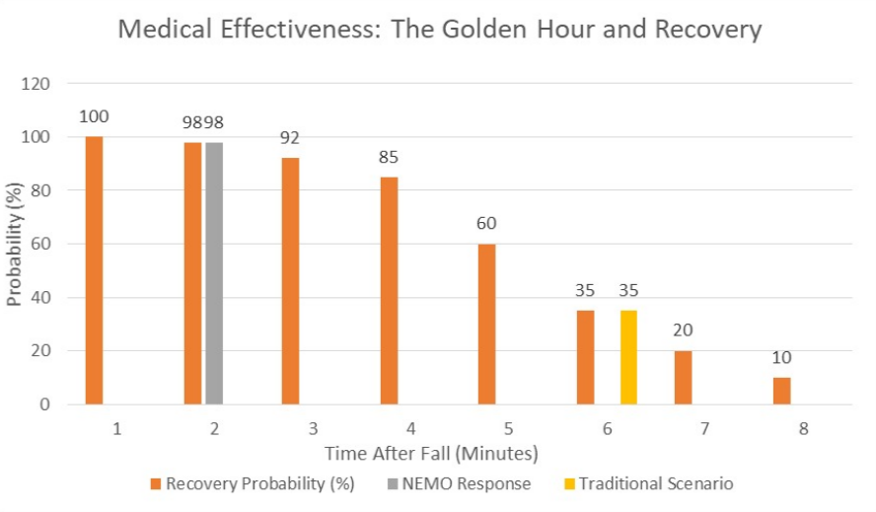

### **3. HARDWARE CONTROL ARCHITECTURE**

The system is engineered on a **Distributed Computing Model**, separating high-level logic from real-time electromechanical actuation.



#### **3.1. The "Brain" (High-Level Controller)**

* **Raspberry Pi 4 (2GB):** Acts as the central gateway. To optimize costs and accessibility for the end-user, we utilize a **"Thin Client" strategy**. The RPi streams low-latency sensor data to the cloud via **LiveKit**, ensuring that complex multimodal analysis (Gemini AI) runs on high-performance servers without depleting the robot's onboard power.

#### **3.2. The "Nervous System" (Low-Level Driver)**

* **Arduino Uno + CNC Shield:** A dedicated real-time controller connected via Serial (USB). It is responsible for:
  + **Actuation:** Precision control of DC motors via PWM signals.
  + **Safety Override:** Direct hardware control over the **GSM SIM Shield**. Even in the event of a main operating system failure, the Arduino can trigger a physical cellular call.
  + **Social Mechanics:** Control of the Pan-Tilt servo mechanism to orient the camera towards the user.

#### 

#### **3.3. Sensory Suite**

* **Vision:** Wide-angle optical sensor for video streaming and AI analysis.
* **Audio:** 8-Mic Array for 360° sound localization.
* **Connectivity:** Triple-channel redundancy — Wi-Fi (Telemetry), Internet API (Telegram Bot), and GSM (Emergency Backup).

#### **3.4. Industrial Design & CAD Engineering**

The visual identity and mechanical structure of NEMO were developed using professional-grade PLM software to ensure precision and structural integrity.

* **Software Stack:** The entire project was modeled using **PTC Creo Parametric 9.0 (Educational Edition)**.
* **Design Concept:** The aesthetic of the robot is a tribute to the cinematic design seen in the film *"The Lightning Code"*. While the visual concept was inspired by these references, the engineering execution was performed independently.
* **Modeling Process:** Every component was modeled from scratch based on photographic analysis. This involved creating individual part files (.prt) for the chassis, internal brackets, and the pan-tilt head mechanism. These were then integrated into a complex global assembly (.asm).
* **Engineering Considerations:** * **Hardware Integration:** Specific internal cutouts and mounting points were designed to house the Raspberry Pi 4, Arduino Uno, and the 3-wheel motor system.
  + **Prototyping:** The model accounts for the exact dimensions of the JGA25 motors and sensor offsets, ensuring that the physical assembly matches the digital twin without mechanical interference.
  + **Scalability:** The design includes modular mounts for the upcoming Lidar integration, allowing for future hardware upgrades without structural changes.

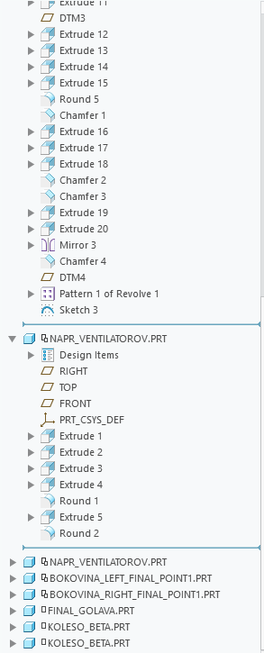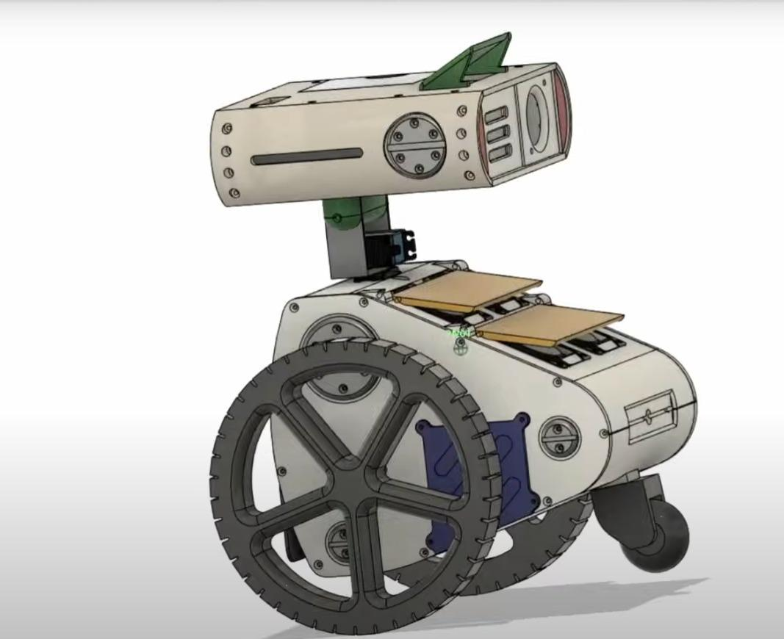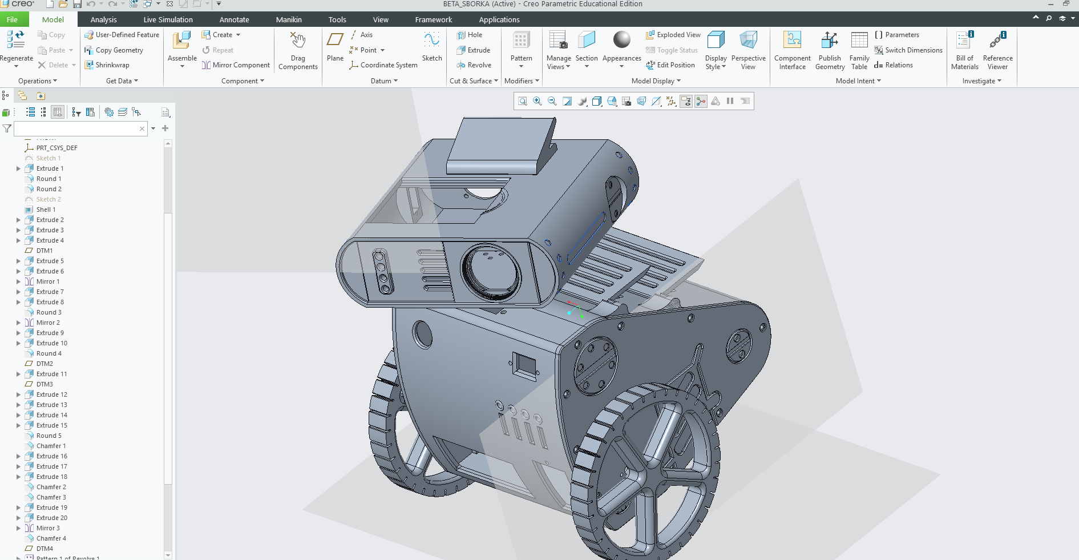

### **4. SOFTWARE STACK & IMPLEMENTATION**

#### **4.1. Hybrid Intelligence Pipeline (LiveKit + Gemini)**

To overcome the limitations of local edge computing, the project implements a low-latency data pipeline:

1. **Ingest:** The robot captures video and audio streams via WebRTC (LiveKit).
2. **Process:** The Cloud Server analyzes frames using **Gemini 1.5 Pro**.
3. **Analyze:** The AI determines context (e.g., "Subject detected on floor," "Signs of distress," "Hand wave gesture").
4. **React:** The server transmits structured commands back to the Raspberry Pi to trigger hardware responses.



#### **4.2. Multi-Channel Alert Logic (Telegram + GSM)**

We implemented an **Escalation Protocol** to avoid false alarms and ensure information delivery.

* **Level 1: Pre-Warning (Telegram API).** If the AI detects an anomaly (e.g., prolonged inactivity or "strange state"), the Python script captures a snapshot and sends it to a private Telegram group via Bot API.
  + *Message content:* Photo of the scene + AI assessment text (e.g., "Attention: User has been lying on the sofa for 4 hours").
* **Level 2: Critical Alert (Hardware Control).** If the AI detects a verified fall or receives no response after the Level 1 warning, the system escalates to a hardware trigger.

#### **4.3. Hardware Control Logic (The Serial Bridge)**

This component is the core of the "Hardware Control" category entry. A custom Python driver on the Raspberry Pi translates AI intents into byte-code for the Arduino.

* **Logic Flow:** AI_Critical_Event → Python Script → Serial Write (b'CALL_SOS') → Arduino Interrupt → GSM Module Activation

This direct hardware bridge ensures that safety-critical features operate with minimal latency even if internet services are disrupted.

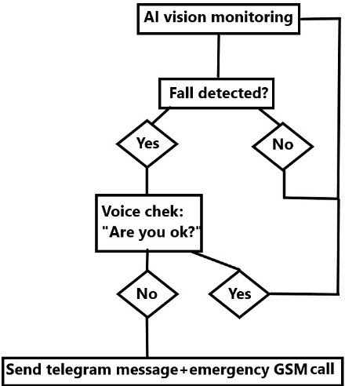

### **5. CURRENT CAPABILITIES vs. ROADMAP**

The development of NEMO follows a strict engineering roadmap to ensure reliability and scalability.

#### **Phase 1: The "Digital Guardian" (Current / MVP Status)**

* **Remote Telepresence:** Relatives or medical personnel can remotely control the robot ("Mobile Avatar" mode) to inspect the premises.
* **Smart Notifications:** Automated Telegram alerts with photo evidence of the user's status.
* **GSM Safety Net:** Autonomous emergency calls triggered by critical AI analysis.
* **Social Interaction:** Voice dialogue and head movements driven by LLM context.

#### **Phase 2: Autonomous Patrolling (In Development)**

We are currently integrating the **ROS 2 (Robot Operating System)** Navigation Stack to enable full autonomy.

* **Sensor Fusion:** Combining data from **Wheel Odometry** (encoders) and **Lidar (RPLidar A1)**.
* **SLAM:** Implementation of *Gmapping* or *Cartographer* algorithms for static map generation.
* **Nav2 Stack:** Enabling dynamic path planning for scheduled patrolling (e.g., Kitchen to Bedroom), with real-time obstacle avoidance.

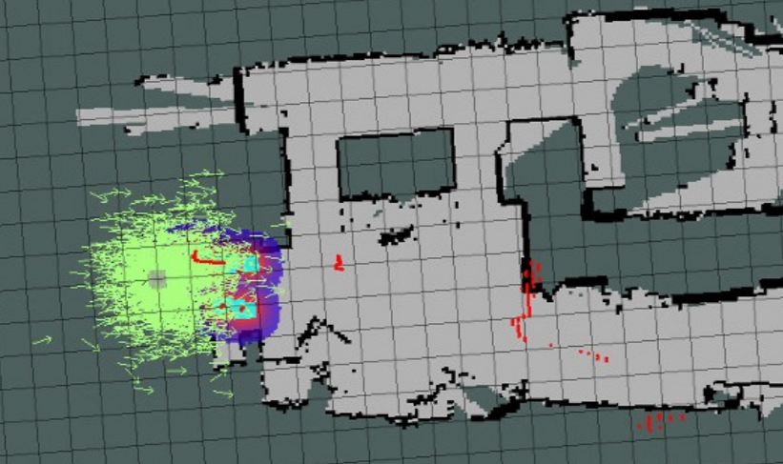

*Note: The hardware interfaces and software nodes for Lidar integration are already architected into the current build.*

### **6. INNOVATION & SOCIAL VALUE**

* **Cost Efficiency:** By offloading computation to the cloud, the project avoids expensive hardware (e.g., Jetson Nano), making the device affordable for pension-level incomes.
* **Privacy by Design:** Video is processed securely; raw footage is not stored permanently.
* **Active Safety:** Unlike a static camera, NEMO physically moves to verify the status of a silent user, eliminating "blind spots."

### **7. CONCLUSION**

NEMO demonstrates that effective **Hardware Control** is achieved through the intelligent orchestration of disparate systems. By bridging a robust Arduino-controlled chassis with the scalable power of Cloud AI and modern messaging APIs (Telegram), we have created a life-saving device that addresses one of the most pressing demographic challenges of the 21st century.

### **8. REFERENCES & TECH STACK**

* **Languages:** Python (High-level logic), C++ (Firmware).
* **Frameworks:** ROS 2, MediaPipe, LiveKit, Telegram Bot API.
* **Hardware:** Raspberry Pi 4, Arduino Uno, SIM800L Module, JGA25 Motors.